**Лабораторная работа № 3.**

**Запросы SQL.**

1. Постановка задачи

Создать запросы.

Результаты выполненной работы

При вводе:

• [SELECT * FROM "users" WHERE 1](http://192.168.0.197:8888/pla/phpliteadmin.php?table=users&action=table_sql)

• [SELECT * FROM "users" WHERE id>=2](http://192.168.0.197:8888/pla/phpliteadmin.php?table=users&action=table_sql)

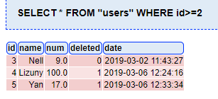

• [SELECT * FROM "users" WHERE name='Nell'](http://192.168.0.197:8888/pla/phpliteadmin.php?table=users&action=table_sql)

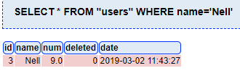

• [INSERT INTO "users" ("name","num","deleted") VALUES ('Yan','17.0','1');](http://192.168.0.197:8888/pla/phpliteadmin.php?table=users&action=table_sql)

• [UPDATE "users" SET num="19.0" WHERE id="1"](http://192.168.0.197:8888/pla/phpliteadmin.php?table=users&action=table_sql)

• [DELETE FROM "users" WHERE id=2](http://192.168.0.197:8888/pla/phpliteadmin.php?table=users&action=table_sql)

У нас в конечном результате получилась таблица:



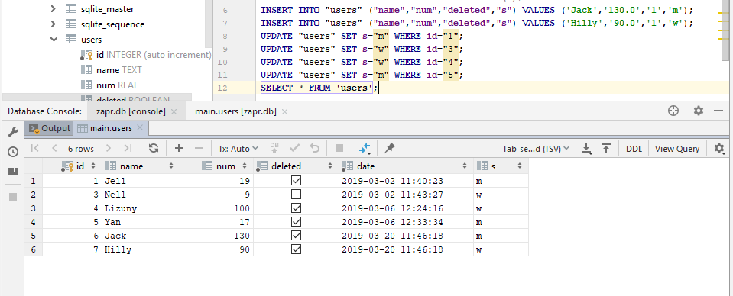

**SELECT** *\** **FROM 'users' WHERE num BETWEEN** 17 **AND** 20

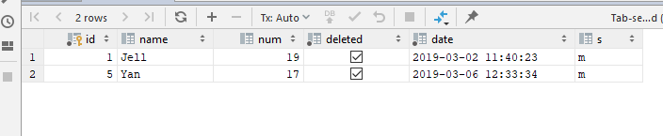

**SELECT** *\** **FROM 'users' WHERE name NOT LIKE 'J%'**

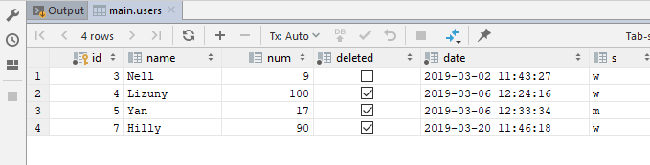

**SELECT** *\** **FROM 'users' WHERE num**<=9 **OR num** >= 20;

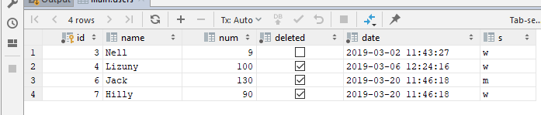

**SELECT id**,**name**,*sum*(**num**),**s FROM 'users' GROUP BY s**;

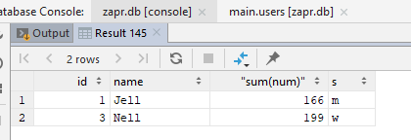

**SELECT id**,**name**,*sum*(**num),s** **FROM 'users' WHERE id** > 3 **GROUP BY s**;

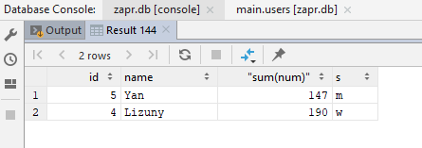

**SELECT id**,**name**,*sum*(**num**),**s FROM 'users' GROUP BY s HAVING** *sum*(**num**)>=190;

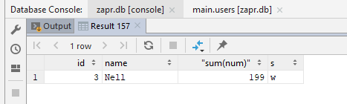

**SELECT** *\** **FROM** "users" **ORDER BY num DESC**;

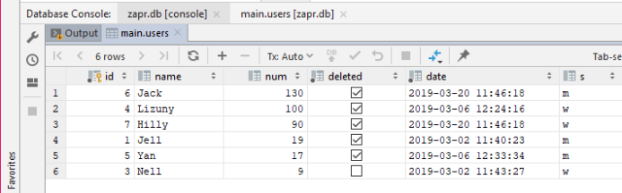

**SELECT** *\** **FROM** "users" **ORDER BY num ASC**;

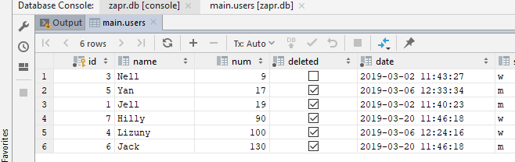

**SELECT** *\** **FROM** "users" **ORDER BY name**;

